HEATING AND COOLING

Heat and Temperature

• These are NOT the same.

Heat: the total of the potential and kinetic energy (internal energy) of the particles in a
substance.

Temperature: a measure of the average kinetic energy of the particles in a substance.

• The amount of heat held varies with the type of substance.

e.g. Metals hold quite a lot of heat, but water holds much more. Hence, it takes more heat to
change the temperature of the water than a metal.

Example

A group of students held a large metal nut in a Bunsen flame and heated it to red heat (~ 400 °C). They then placed it carefully into 50 mL of water at 20 °C. The water temperature rose only to
35 °C.

Hence the metal may have been much hotter in temperature but it didn't hold much heat as it only changed the water temperature by a small amount.

• Heat always flows from the higher temperature area to the lower temperature area.

e.g. Your hand is about 35 °C and a bench top is 20 °C. When you touch the bench, heat
flows from your hand into the bench until both are at the same temperature.

The bench feels cold as the heat is drawn out of your hand.

• Heat is transferred in three ways.

Conduction

• Occurs in solids where particles vibrate in fixed positions.
• Energy is transferred by particles colliding and transferring kinetic energy.
• As the amount of kinetic energy in the particles increases, a temperature rise if felt.

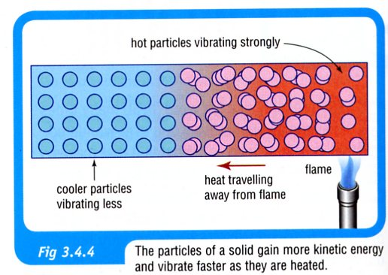
• Some substances are better conductors of heat than others.

e.g. Metals are very good conductors.
Plastics, glass, wood and other similar materials (non-metals) are insulators - very poor
conductors.

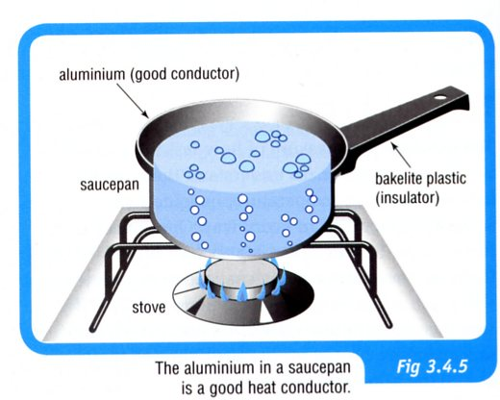

• Liquids and gases are very poor conductors - their particles are further apart and more
mobile so they collide far less.

Hence they use another method to transfer heat.

Convection

• Used to transfer heat in liquids and gases.
• Heated particles not only gain kinetic energy but they move further apart, becoming less
dense and rising to the top of the liquid or gas.
• Cooler, more dense liquid or gas moves in at the bottom to take the place of the rising
particles.
• Hot particles at the top start to cool and become denser, falling back down to the bottom.

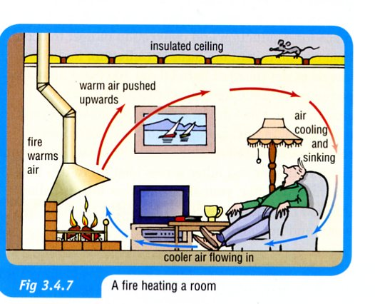
• Land and sea breezes are caused by unequal heating of the land and water.

i.e. If the sea is warmer, hot air rises over it and a land breeze moves out to sea.
If the land is warmer, a sea breeze moves in.

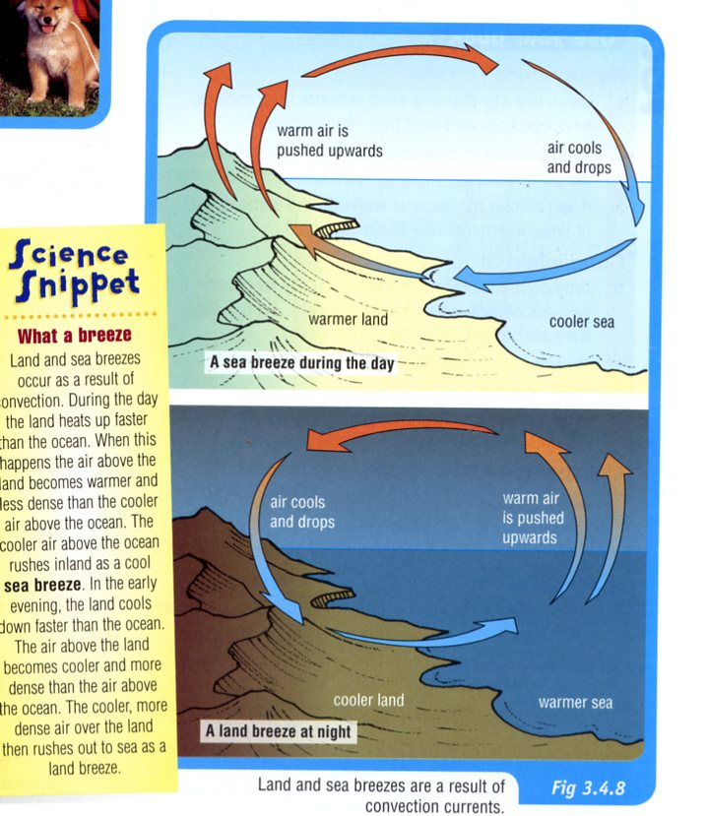

Radiation

• Heat is radiated from objects as infra-red light.
• Being light, it is able to be transmitted through space or the air at about 300,000 km/sec.
• All objects with heat in them will radiate the heat, and infra-red cameras and film will detect
them.
• Infra-red radiation can be reflected, absorbed or transmitted through objects or surfaces that it
hits.
• Black surfaces absorb and radiate heat better than lighter surfaces.

